Big O is how efficient a code is to execute a task.
Time complexity is measured by number of operations to execute a task. Not the time it takes to run.
Space Complexity memory required to execute a task

scenarios – Omega Ω , theta Θ amd Omicron Ο
Assume you are looping from 1 to 7
Omega is best case scenario Ω

Theta is mid case scenario

and Omicron is worst case scenarios

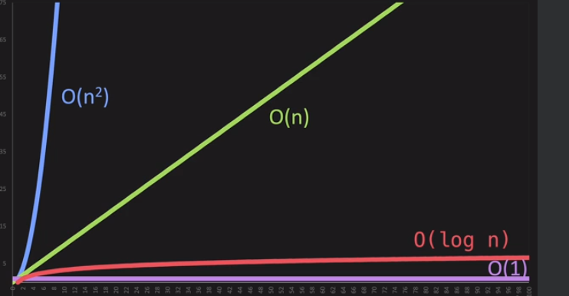

O(n) - Proportional

def print_items(n):
for i in range (n):
print(n);

print_items(10);

drop Constants

def print_items(n):
for i in range (n):
print(n);

for j in range (n):
print(n);

print_items(10);

n + n = 2n -- 2 dropped
o(2n)

O(n²)

n*n = n^2

def print_items(n):
for i in range (n):
for j in range (n):
print(i,j)

print_items(10);

drop non dominants

# n*n + n² = n + n ==> n²

O(log n).py
Data has to be sorted

if we have 8 items 2^3 = 8
means we ill go through 3 steps to find the value

log2 8= 3

Different Inputs

# O(a+b)

def print_ites(a,b):
for i in range (a):
print(i);

for j in range (b):
print(j);

print_ites(2,10)

# O(a*b)
def print_items(a,b):
for i in range (a):
for j in range (b):
print(i,j)

print_items(2,10)

